“RESARCH CONNECT”

Project Report submitted for the partial fulfilment of grade for the course

Data Structures and Algorithms -3 (25CS2103E)

in

DEPARTMENT OF COMPUTER SCIENCE ENGINEERING

by

K.V KOUSHAL :2520030009

Y. CHARAN SAI :2520030173

K. SHASHANK :2520030215

Team Number:
Section:8

Under the Guidance of

Dr. V. SIREESHA
Professor
Department of Computer Science and Engineering





2026-27

DEPARTMENT OF COMPUTER SCIENCE ENGINEERING

Declaration

The Project Report entitled “RESARCH CONNECT” is a record of Bonafide work of K.V. KOUSHAL – 2520030009, Y. CHARAN SAI – 2520030173, B. SHASHANK – 2520030215 submitted in partial fulfillment for the award of B. Tech in Computer Science and Engineering. The results embodied in this report have not been copied from any other departments/University/Institute.

K.V. KOUSHAL:2520030009
Y. CHARAN SAI: 2520030173
B. SHASHANK:2520030215

DEPARTMENT OF COMPUTER SCIENCE ENGINEERING

CERTIFICATE

This is certify that the mini project-based report entitled “RESEARCH CONNECT” is a bonafide work done and submitted by K.V. KOUSHAL – 252030009, Y. CHARAN SAI – 2520030173, B. SHASHANK – 2520030215 in partial fulfillment of the requirements for the award of the degree of BACHELOR OF TECHNOLOGY in Department of Computer Science Engineering, during the academic year 2026-27.

K.V. KOUSHAL:2520030009
Y. CHARAN SAI: 2520030173
B. SHASHANK:2520030215

Signature of the Guide Signature of the HOD
(Dr. V. SIREESHA)

Signature of the External Examiner
ACKNOWLEDGEMENT

We would like to express our sincere gratitude to our project guide, Dr. V. SIREESHA, Professor, Department of Computer Science and Engineering, for his valuable guidance, continuous support, encouragement, and constructive suggestions throughout the development of our project “Research Connect.” His technical knowledge and guidance helped us understand the project requirements, implement the necessary Data Structures and Algorithms, and successfully complete the project work. We also extend our sincere thanks to Dr. P. Venkateshwara Rao, Associate Professor and Head, Department of Computer Science and Engineering, for providing the necessary support, facilities, and encouragement to carry out this project successfully. His valuable guidance and administrative support created a positive environment for completing the project. Finally, we would like to thank the faculty members of the Department of Computer Science and Engineering, our friends, and everyone who directly or indirectly supported us during the development of this project. Their encouragement and cooperation contributed significantly to the successful completion of Research Connect.

K.V KOUSHAL:2520030009
Y. CHARAN SAI: 2520030173
B. SHASHANK:2520030215

Abstract

Research Connect is an algorithm-based research paper discovery and analysis system developed to help students, academicians, and researchers find relevant research papers efficiently. Finding suitable research papers from a large collection can be difficult and time-consuming when conventional search techniques are used. Research Connect addresses this problem by applying Data Structures and Algorithms to different stages of research-paper discovery The system provides facilities for searching research papers using keywords and paper information such as title, author, and research domain. It implements the Knuth-Morris-Pratt (KMP) algorithm for efficient exact keyword searching, Aho-Corasick for multiple keywords searching, Levenstein Edit Distance for typo-tolerant searching, Suffix Array with Longest Common Prefix (LCP) for similarity detection, and graph algorithms for analyzing citation relationships. Hashing and inverted indexing are used to improve candidate paper retrieval. The system contains a collection of research paper documents organized by title, author, year, category, and content. A React-based frontend provides an interactive interface, while a Java Spring Boot backend handles data processing, algorithms, and REST API communication. The system demonstrates how fundamental DSA concepts can be applied to a practical research-paper discovery problem. The project provides fast searching, typo-tolerant matching, similar-paper recommendations, citation analysis, filtering, and statistical information about the research-paper collection. It demonstrates the practical significance of DSA algorithms in developing efficient information retrieval systems.

Table of Contents

 |  |  | Page No.
 | Acknowledgement
 | Abstract
 | Table of Contents
 | List of Figures
1 | Introduction | 1.1 Overview  1.2 Problem statement  1.3 Scope of the project  1.4 Objectives | 5-15
2 | System Requirements | 2.1 Functional Requirements  2.2 Non-Functional Requirements | 16-21
3 | System Design | 3.1 High-level Architecture Diagram  3.2 Description of each layer | 33-36
4 | Implementation | 4.1 Module-wise implementation  4.2 Front-end logic (UI rendering, state management)  4.3 API integration  4.4 ……. | 38-47
5 | Results |  | 56-64
6 | Challenges & Limitations | 6.1 Issues faced during development  6.2 Solutions applied  6.3 Limitations of the System | 74-82
7 | Conclusion & Future Work | 7.1 Conclusion  7.2 Future Work  7.3 Skills learned during development | 89-97
 | References | - Books, tutorials, APIs, documentation sites used | 98-99

List of Figures

1.1 Block Diagram of a Recommendation System 3
1.2 Components of a Recommendation System 6
1.3 Flow Chart to show the working of a Recommendation System 7
1.4 Phases of a Recommendation System 8
1.5 User-User KNN based Recommendation System 13
1.6 Item-Item KNN based Recommendation System 14
1.7 Matrix Factorization based Recommendation System 40

- INTRODUCTION

  - Overview
The rapid growth of scientific and technical publications has resulted in a large amount of research information being available to students, researchers, and academicians. Although research papers are easily accessible, finding the most relevant paper from a large collection can be challenging and time-consuming. Users may need to search using keywords, compare similar papers, identify related research areas, and understand citation relationships. Research Connect is an algorithm-based research paper discovery and analysis system developed to make the process of searching and exploring research papers more efficient and organized. The system applies Data Structures and Algorithms to different stages of research-paper discovery. It supports searching based on keywords, title, author, and research domain and provides additional facilities such as typo-tolerant search, similar-paper recommendations, citation analysis, filtering, and research statistics. The system integrates several DSA techniques including Knuth-Morris-Pratt (KMP), Aho-Corasick, Levenstein Edit Distance, Suffix Array, Longest Common Prefix (LCP), Hashing, Inverted Indexing, BFS, and DFS. A React.js frontend provides an interactive user interface, while a Java Spring Boot backend performs data processing, algorithm execution, and REST API communication. Research connect documentation The project currently operates on a controlled corpus of 180 research papers, consisting of 15 foundational papers and 165 synthetic research papers. The corpus includes domains such as artificial intelligence, natural language processing, cybersecurity, quantum computing, robotics, and cloud computing.

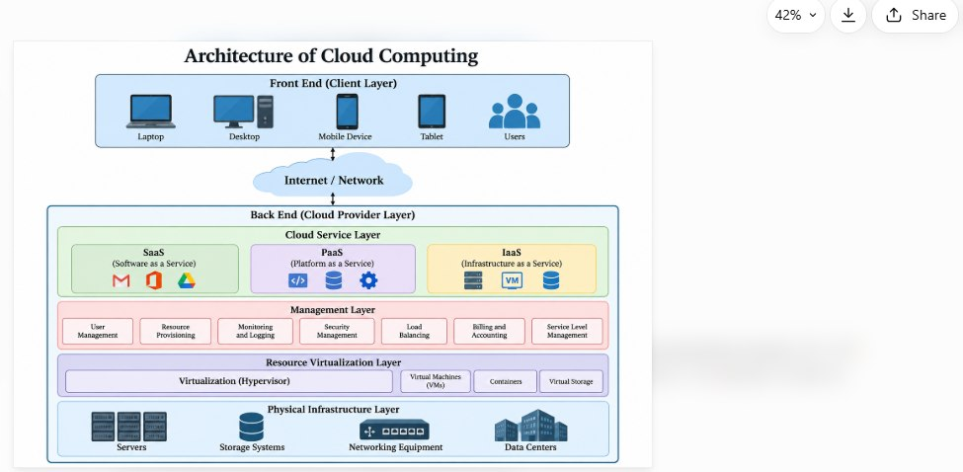
Fig. 1.1 Architecture of Cloud
1.2 Problem Statemen
Finding relevant research papers from a large collection is difficult when users must manually inspect multiple documents. Traditional keyword-based search methods may also produce unsatisfactory results when a user enters a spelling mistake or wants to discover papers related to a particular topic rather than searching for an exact keyword. Another challenge is the analysis of relationships between research papers. Users may need to identify similar papers, explore citation relationships, and filter papers according to year or research category. Therefore, an efficient system is required that combines multiple searching, indexing, similarity detection, and graph-based techniques within a single research-paper discovery platform.

1.3 Scope of the Project
The scope of Research Connect includes research-paper searching, document analysis, similarity detection, recommendation, filtering, and citation-network exploration.
The system supports:
- Keyword-based research-paper searching.
- Multiple-keyword searching.
- Typo-tolerant searching.
- Search suggestions and autocomplete.
- Similar research-paper recommendations.
- Citation relationship analysis.
- BFS and DFS citation traversal.
- Filtering based on publication year and research category.
- Research-paper statistics.
- Interactive paper browsing.
- Detailed paper viewing.
- Demonstration of DSA algorithms.

1.4 Objectives
The major objectives are:
- Fast and efficient research-paper searching.
- Research-paper search based on title, author, keyword, and research domain.
- KMP implementation for exact keyword searching.
- Aho-Corasick implementation for multiple-keyword searching.
- Spelling-error handling using Levenstein Edit Distance.
- Similar research-paper identification and recommendation.
- Suffix Array and LCP techniques for similarity detection.
- Citation relationships represented using a directed graph.
- BFS and DFS techniques for citation-network traversal.
- Filtering based on publication year and research category.
- Hashing and inverted indexing for rapid candidate retrieval.
- Practical demonstration of Data Structures and Algorithms in a real-world research-paper discovery system

- SYSTEM REQUIREMENTS
2.1 Functional Requirements
- FR1 – Paper Search: Search research papers using keywords.
- FR2 – Paper Filtering: Filter papers based on publication year and research category.
- FR3 – Exact Search: Locate exact keyword occurrences using the KMP algorithm.
- FR4 – Multiple Keyword Search: Search multiple keywords simultaneously using the Aho-Corasick algorithm.
- FR5 – Typo-Tolerant Search: Identify possible intended words when the user enters a misspelled keyword using Edit Distance.
- FR6 – Similar Paper Recommendation: Identify and recommend papers containing similar textual patterns.
- FR7 – Citation Analysis: Display citation relationships between research papers.
- FR8 – Citation Traversal: Support BFS and DFS traversal of the citation graph.
- FR9 – Statistics: Provide information about papers, categories, publication years, authors, and citations.
2.2 Non-Functional Requirements
- Performance: Efficient search processing with minimum unnecessary document scanning.
- Usability: Simple and understandable interface for students, researchers, and academicians.
- Reliability: Consistent results for the same search operation and research-paper corpus.
- Scalability: Support for adding more research papers to the corpus.
- Maintainability: Separate organization of DSA algorithms into Java classes for easier testing and modification.
2.3 Hardware Requirements
The minimum hardware requirements are:
- Intel Core i3 processor or above.
- Minimum 4 GB RAM.
- Approximately 500 MB free storage.
- Standard desktop or laptop computer.
2.4 Software Requirements
The software technologies used in the project are:
- Java
- Spring Boot
- Maven
- React.js
- Vite
- JavaScript
- HTML
- CSS
- Node.js
- npm

3. SYSTEM DESIGN
3.1 High-Level Architecture
Research Connect follows a layered full-stack architecture consisting primarily of the React.js frontend, Java Spring Boot backend, DSA processing modules, indexes/data structures, and research-paper corpus. The frontend is responsible for user interaction and presentation. The React.js interface allows users to search papers, apply filters, view paper details, explore recommendations, and analyse citation relationships. The Java Spring Boot backend acts as the main processing layer. REST controllers receive requests from the frontend and forward them to the appropriate service components. The service layer executes the required DSA algorithms and returns the processed results to the frontend. The research-paper corpus contains information such as title, author, publication year, research category, content, and citation relationships. Hash-based structures and inverted indexes are maintained to improve retrieval efficiency.

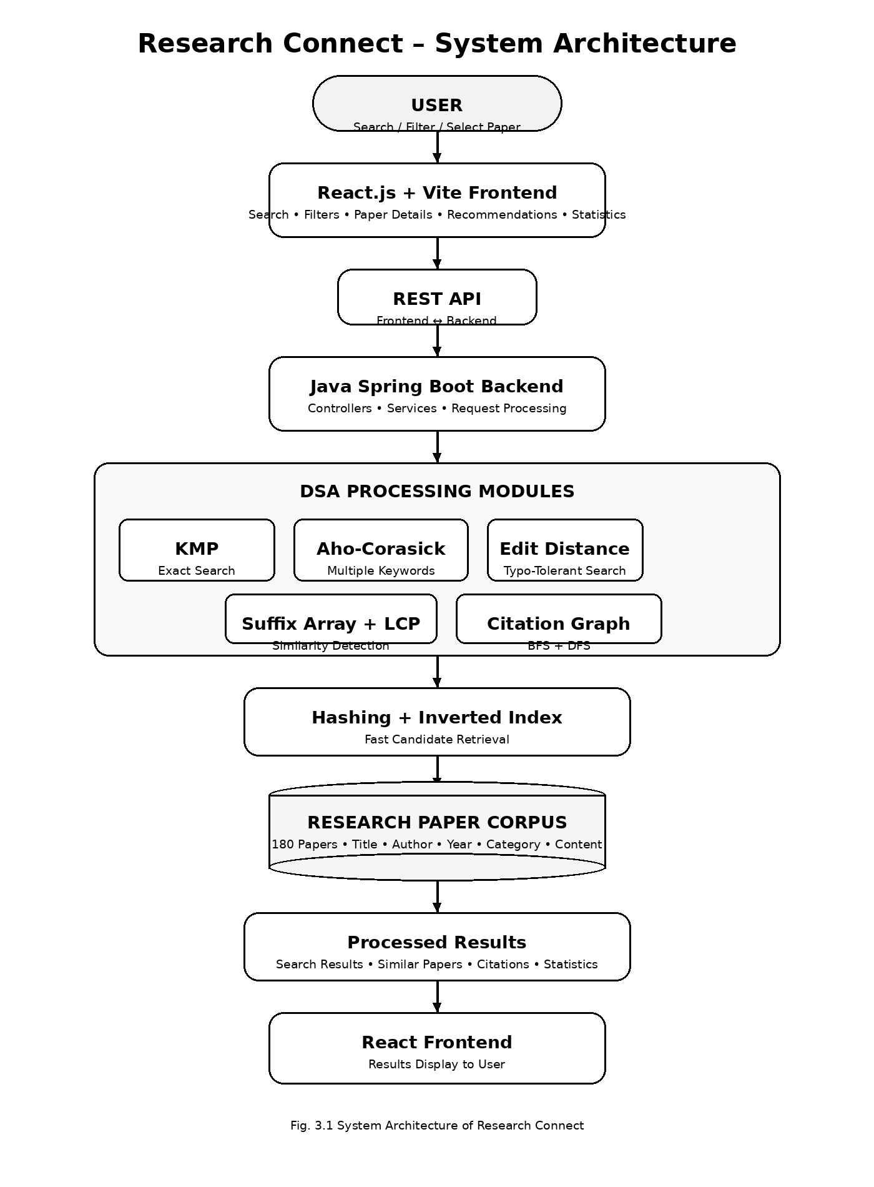

Presentation Layer
The presentation layer is developed using React.js and Vite. It provides the user interface for searching papers, viewing results, applying filters, accessing recommendations, and exploring citation information.
Application Layer
The Java Spring Boot backend provides the application-processing environment. REST controllers receive requests and forward them to relevant services.
Algorithm Layer
This layer contains the major DSA implementations, including KMP, Aho-Corasick, Edit Distance, Suffix Array and LCP, BFS, DFS, hashing, and inverted indexing.
Data Layer
The data layer contains the research-paper corpus and associated information such as paper identifiers, titles, authors, categories, publication years, content, and citation relationships.

3.3 Data Structures Used
- HashMap: Used for efficient mapping and retrieval of research-paper information using paper identifiers.
- HashSet: Used to maintain unique paper identifiers in the inverted index and avoid duplicate entries.
- Trie: Used for vocabulary management, prefix-based searching, search suggestions, and autocomplete.
- Queue: Used in Aho-Corasick failure-link construction and Breadth-First Search (BFS) traversal.
- Directed Graph: Used to represent citation relationships, where research papers are vertices and citations are directed edges.
- Arrays: Used in KMP's LPS array, Suffix Array, LCP array, and Edit Distance dynamic-programming table.
4. IMPLEMENTATION
4.1 Module-Wise Implementation
Research Connect is implemented using several major modules:
- Research Paper Loading Module
- Search Module
- Multiple Keyword Search Module
- Typo-Tolerant Search Module
- Similarity Detection Module
- Citation Analysis Module
- Filtering Module
- Recommendation Module
- Statistics Module
- Frontend and REST API Module

4.2 Research Paper Loading
The implementation starts by loading research papers from the controlled corpus. Each paper is processed to obtain its title, author, publication year, research category, and textual content. Each paper is converted into an internal paper object and stored in the system. Hash-based structures associate paper identifiers with their corresponding paper objects for efficient retrieval. The system also constructs an inverted index from the words present in the corpus. A vocabulary and prefix Trie can additionally be created to support autocomplete and search suggestions.
4.3 KMP Algorithm Implementation
The Knuth-Morris-Pratt algorithm is used for exact keyword searching.
The algorithm first constructs an LPS (Longest Prefix Suffix) array for the search pattern. During searching, when a mismatch occurs after some characters have already matched, the LPS array determines the next position from which the pattern comparison should continue. This avoids unnecessary repeated comparisons and provides efficient exact searching.
The time complexity of KMP is:
O (N + M)
where N represents the text length and M represents the pattern length.

4.4 Aho-Corasick Implementation
Aho-Corasick is used for searching multiple keywords simultaneously.
The keywords are first inserted into a Trie. After constructing the Trie, failure links are generated using a queue-based breadth-first process. During searching, the research-paper text is scanned, and the algorithm follows Trie transitions and failure links. Whenever a terminal node corresponding to a keyword is reached, that keyword is reported as a match. This allows multiple research terms to be processed during a single traversal.
4.5 Edit Distance Implementation
Levenstein Edit Distance is implemented to handle spelling mistakes in user queries.
The algorithm calculates the minimum number of insertion, deletion, and substitution operations required to transform one string into another. A two-dimensional dynamic-programming table is used. The final cell represents the minimum editing distance between the two strings. Research Connect compares user-entered words with indexed vocabulary terms and can identify possible corrections.
4.6 Suffix Array and LCP Implementation
The similarity module uses Suffix Array and Longest Common Prefix techniques to identify common textual patterns. A Suffix Array stores starting positions of suffixes in sorted order. The LCP array stores the length of the common prefix between neighbouring suffixes. The common patterns identified using these structures are used to generate similarity information between research papers and support similar-paper recommendations.
4.7 Citation Graph Implementation
Citation relationships are represented using a directed graph.
Each research paper is represented as a node, and a citation from one paper to another is represented by a directed edge.
For example:
Paper A → Paper B
indicates that Paper A cites Paper B.
BFS is used to explore citation relationships level by level, while DFS explores citation paths more deeply before backtracking.

4.8 Hashing and Inverted Index
An inverted index maps a keyword to the collection of paper identifiers in which that keyword occurs.
For example:
transformer → Paper 1, Paper 5, Paper 12
When a user searches for a particular term, the system can first obtain candidate paper identifiers from the inverted index rather than examining every paper in the collection. This reduces unnecessary processing and improves candidate retrieval efficiency
4.9 Front-End Logic
The frontend is implemented using React.js. Separate interface components are provided for:
- Research-paper search
- Advanced search
- Paper details
- Similar papers
- Citation information
- Statistics
- Algorithm information
The frontend sends requests to the backend through REST APIs. The returned information is displayed through search-result cards, paper information sections, recommendation sections, and citation-network information.
4.10 API Integration
The frontend communicates with the Java Spring Boot backend through REST Apis. When the user performs an operation, the frontend sends the relevant request to the backend. The backend controller receives the request and forwards it to the appropriate service. The service performs the required DSA processing and returns the result through the REST API. This separation allows the frontend and backend to be developed and maintained independently.
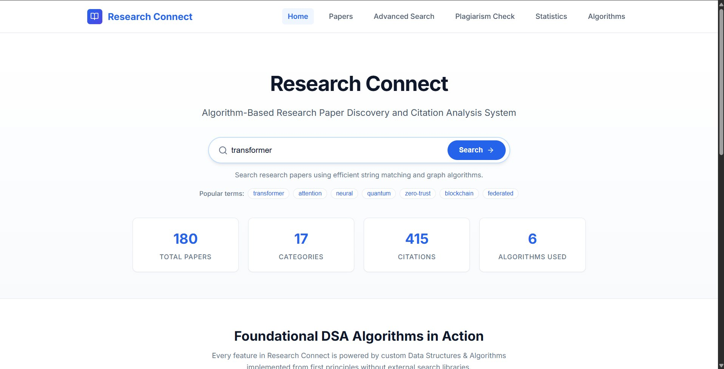

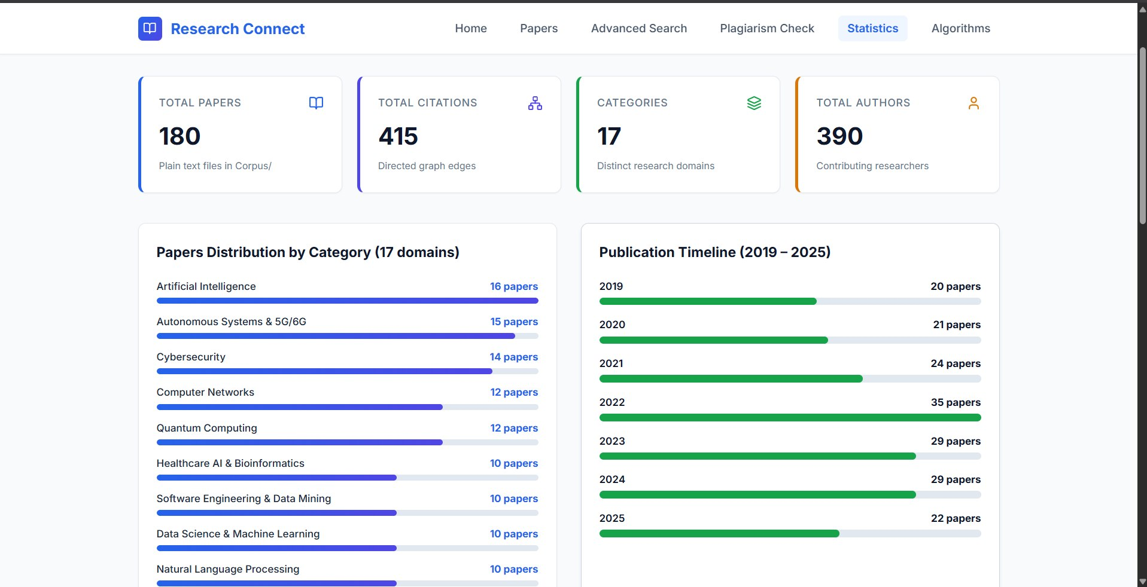
5. RESULTS
5.1 System Results
Research Connect provides an integrated environment for searching, analysing, and discovering research papers. Multiple DSA techniques are combined so that different research-discovery requirements can be handled using appropriate algorithms.
The system successfully demonstrates:
- Exact keyword searching using KMP.
- Multiple-keyword searching using Aho-Corasick.
- Typo-tolerant searching using Edit Distance.
- Similarity detection using Suffix Array and LCP.
- Citation analysis using BFS and DFS.
- Candidate retrieval using hashing and inverted indexing.
- Filtering based on year and research category.
- Research-paper statistics.
5.2 Search Results
KMP-based searching allows users to enter an exact keyword and retrieve research papers containing the requested term. The inverted index further improves the search process by identifying candidate papers associated with a particular keyword before detailed text matching is performed. This avoids unnecessary examination of the complete paper collection.
5.3 Typo-Tolerant Search Results
The Edit Distance module allows the system to handle spelling mistakes in user queries. When a query does not directly match an indexed vocabulary term, the system compares it with available vocabulary terms and identifies terms having a small editing distance.
This improves the flexibility of the search interface and helps users search for technical terms even when they are not entered with exact spelling.
5.4 Multi-Keyword Search Results
The Aho-Corasick algorithm allows multiple research keywords to be processed simultaneously. The keywords are organized into a Trie with failure links, allowing the research-paper content to be searched in a combined traversal rather than separately scanning the collection for each keyword.
5.5 Similar Paper Results
The similarity module uses Suffix Array and LCP techniques to identify common textual patterns between research papers. The resulting similarity information can be used to present related papers after the user selects a particular paper. This helps users continue their research without manually searching for every related document
5.6 Citation Analysis Results
The citation module represents research-paper relationships using a directed graph. BFS provides level-wise exploration of citation relationships, while DFS allows deeper traversal through connected papers. This enables users to discover relationships between papers based not only on their textual content but also on their citation connections.
5.7 Filtering Results
Research Connect provides filtering based on publication year and research category. Users can first search for a research topic and then narrow the results according to a particular period or research domain. This makes the research-paper discovery process more structured.
5.8 Statistics Results
The statistics module provides information about the research-paper corpus, including:
- Number of research papers
- Research categories
- Publication years
- Authors
- Citation relationships
These statistics provide an overview of the available research corpus and help users understand its organization.
6. CHALLENGES AND LIMITATIONS
6.1 Issues Faced During Development
The major challenges encountered during development include:
- Efficiently searching a collection of text documents.
- Handling spelling mistakes in search queries.
- Searching multiple keywords simultaneously.
- Identifying similar documents based on textual content.
- Representing citation relationships between research papers.
- Traversing citation networks efficiently.
- Building an efficient paper-indexing mechanism.
- Integrating DSA algorithms with a web-based interface.
- Managing communication between frontend and backend components.
6.2 Solutions Applied
To address these challenges, appropriate DSA techniques were integrated into the system. MP was used for exact matching, Aho-Corasick for multiple-keyword searching, and Edit Distance for typo-tolerant searching. Suffix Array and LCP were used for similarity detection, while directed graphs with BFS and DFS were used for citation analysis. Hashing and inverted indexing were implemented to reduce unnecessary searching across the complete paper collection. React.js and Spring Boot were integrated through REST APIs to connect the frontend interface with the algorithmic backend.
6.3 Limitations of the System
The current system operates on a controlled research-paper corpus, which limits the size and diversity of available documents. The similarity mechanism is primarily based on textual patterns and may not fully understand the semantic meaning of research content. Citation analysis also depends on the citation relationships available within the corpus. As the number of research papers increases, indexing, memory management, and algorithm optimization become increasingly important.

7. CONCLUSION AND FUTURE WORK
7.1 Conclusion
Research Connect demonstrates the practical application of Data Structures and Algorithms to the problem of research-paper discovery and analysis. The system combines KMP for exact keyword searching, Aho-Corasick for multiple-keyword searching, and Levenstein Edit Distance for typo-tolerant searching. Suffix Array and LCP techniques are used to identify textual similarities, while directed graphs support citation analysis using BFS and DFS and inverted indexing provide efficient candidate retrieval and organization of the research corpus. The integration of these algorithms with a React.js frontend and Java Spring Boot backend demonstrates how theoretical DSA concepts can be transformed into a practical software application. Overall, Research Connect provides an organized environment for research-paper discovery while demonstrating the practical importance of algorithmic problem-solving in information-retrieval systems.

7.2 Future Work
The future scope of Research Connect includes:
- Supporting a larger and continuously updated research-paper database.
- Expanding the research-paper corpus to provide broader search and recommendation capabilities.
- Integrating advanced recommendation and machine-learning techniques with the existing DSA-based similarity methods.
- Improving citation-network visualization through interactive graphs.
- Adding additional filters based on authors, publication year, research domain, keywords, and citation information.
- Integrating additional Natural Language Processing techniques to improve query understanding.
- Improving search accuracy.
- Introducing personalized recommendations based on previous searches and research interests.
- Developing a more advanced user interface.
- Improving citation visualization and research-paper exploration.

7.3 Skills Learned During Development
Through the development of Research Connect, the project team gained practical experience in:
- Data Structures and Algorithms.
- Pattern matching algorithms.
- Graph traversal.
- Hashing and indexing.
- Dynamic programming.
- Text similarity analysis.
- React.js frontend development.
- Java Spring Boot backend development.
- REST API integration.
- Full-stack application development.
- Research-paper information retrieval.
- Software module integration and testing.
REFERENCES / WEB SOURCES
- Google Scholar – Research paper search and scholarly literature
https://scholar.google.com/ Google Scholar
- IEEE Xplore – IEEE research papers, journals and conference publications
https://ieeexplore.ieee.org/ IEEE Xplore
- ACM Digital Library – Computer science research papers and publications
https://dl.acm.org/ ACM
- ScienceDirect – Scientific and technical research articles
https://www.sciencedirect.com/
- SpringerLink – Research articles, journals and conference papers
https://link.springer.com/
- Semantic Scholar – AI-powered academic research search
https://www.semanticscholar.org/
- ResearchGate – Research papers and academic publications
https://www.researchgate.net/
- Stanford Information Retrieval Book – Information retrieval and inverted-index concepts
https://nlp.stanford.edu/IR-book/
